Part 1: First I created a GitHub account then I proceeded to sign up. I then located the computer science workspace folder (as it is a completely secure area that only I can see) where I can work on my project through the PC instead of OneDrive. I then created the folder where I would store my future work.
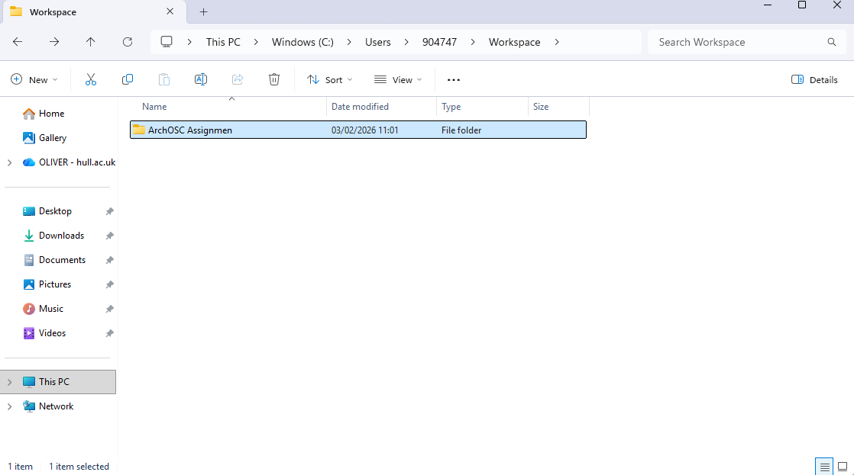

part 2: I opened up the terminal by right clicking on my folder and left clicking “open in terminal, You can also open the terminal by clicking the windows key and typing it into the search bar. I then used the “git init” command to create a local repository that will be used to push my work onto GitHub.
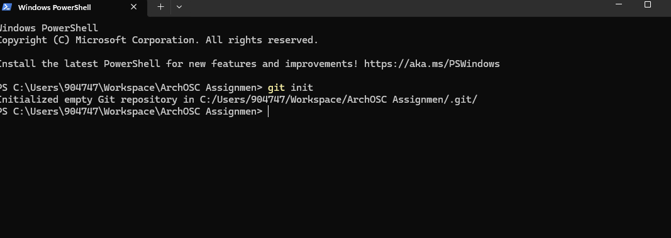

part 3: now I’ve got a local repository I need to create a GitHub repository to link it to. I Pressed the green new button create a repository I then selected myself as the no template name holder and named the repository according to instruction. And finally I set the “readme” file to on and set “add .gitignore” to visual studio and created the repository where I will push and pull my work from

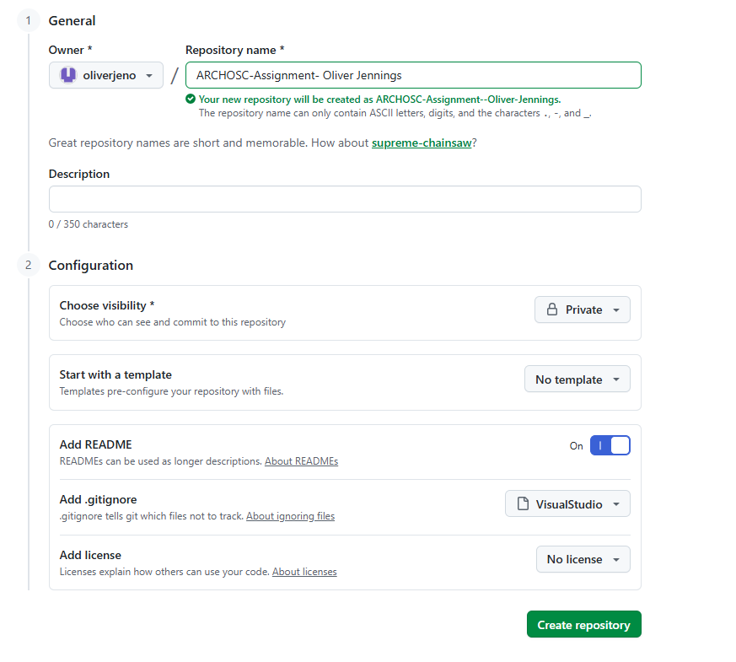

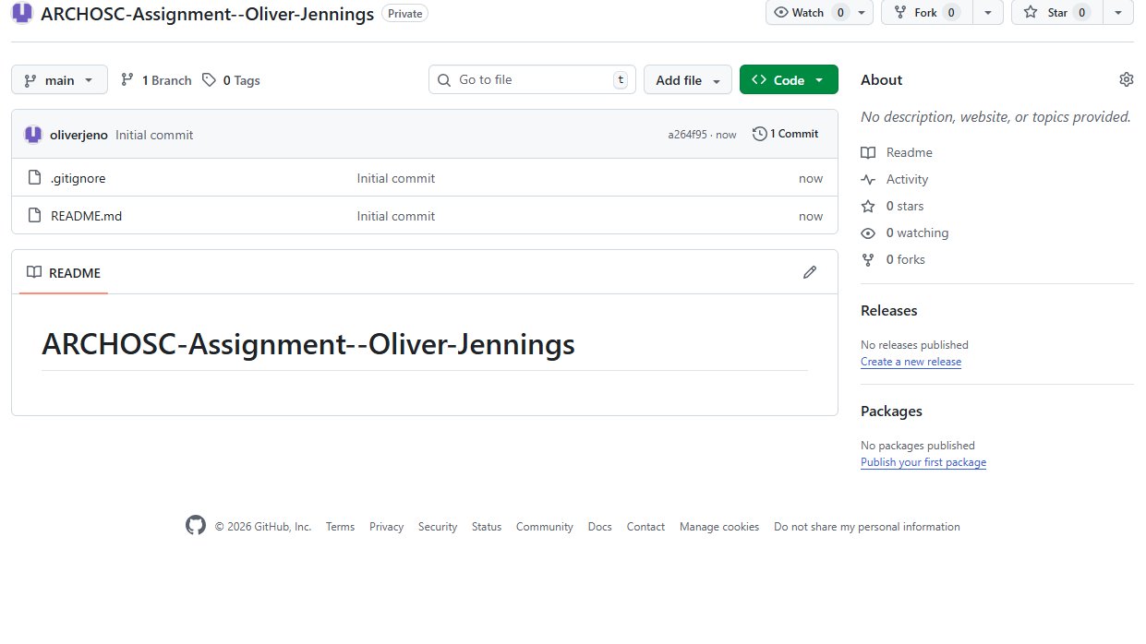

Part 4: I then went back to created a link between my local and online GitHub repository, this is so I can push and pull my work fluidly between the two. I then pulled the files already on GitHub down to my local repository using the “git pull origin main” command in the terminal.
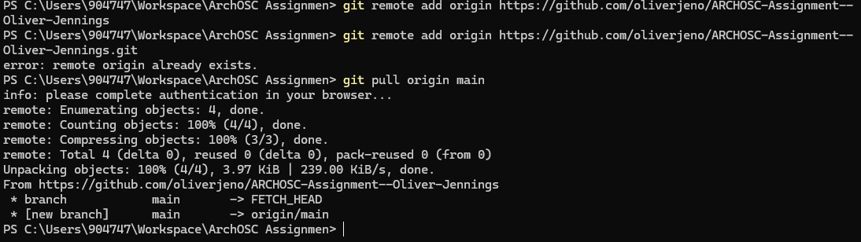

Part 5: I then used visual studio code and pasted some of the html code that would be required for my website. I saved and named the file index.html as instructed.
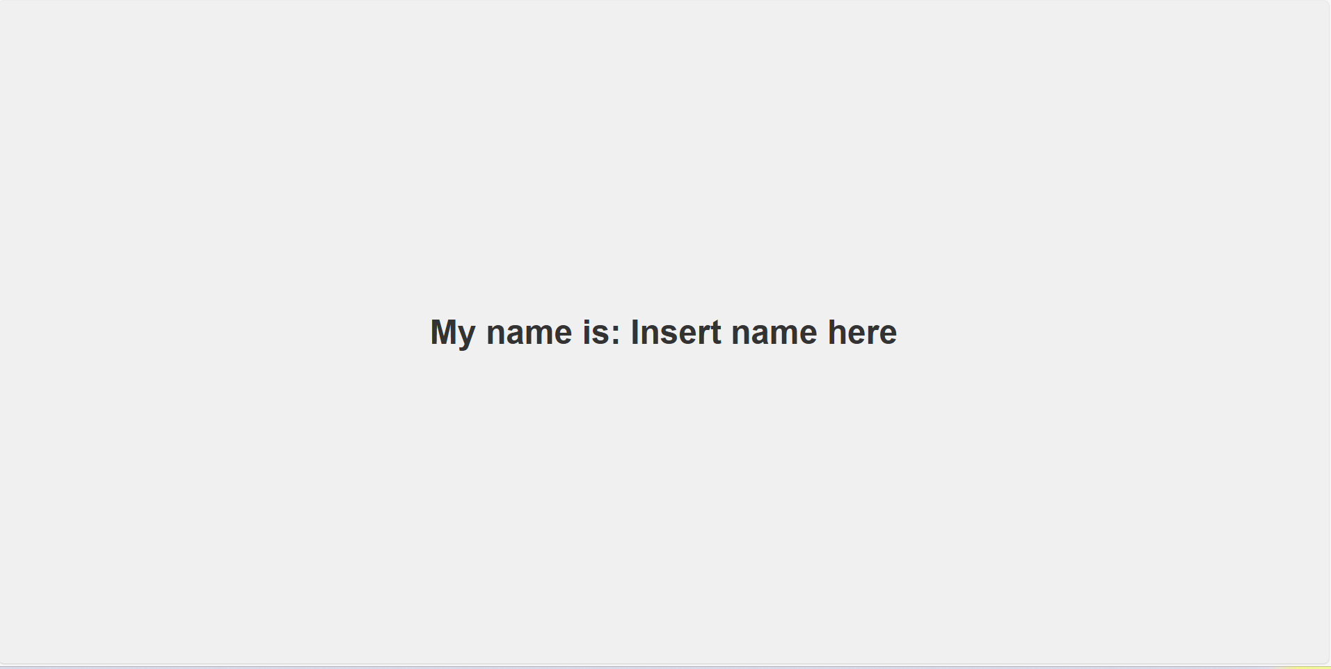
Part 6:
